Member 1: Tenia Xu Yuan (P1935334)

Member 2: Sebastian Pang (P1935631)

SCRUM – Backlog

|  |  |  |
| --- | --- | --- |
| **Priority** | **Story** | **Effort** |
| 3 | As a player, I want to be able to play the game without facing any error so that I can have a smooth game experience. (Game Screen) | 85 |
| 5 | As a player, I want to be able to quit the game or restart the game so that I can stop/restart the game when necessary. | 2 |
| 4 | As a developer, I want the game to run smoothly so that the players can have a smooth game experience. (Troubleshooting) | 30 |
| 1 | As a developer, I want to have a clear game plan so that I do not make unnecessary mistakes in the game development. | 5 |
| 2 | As a developer, I want to be able to utilise the appropriate assets in the game so that it suits the theme of the game. | 5 |

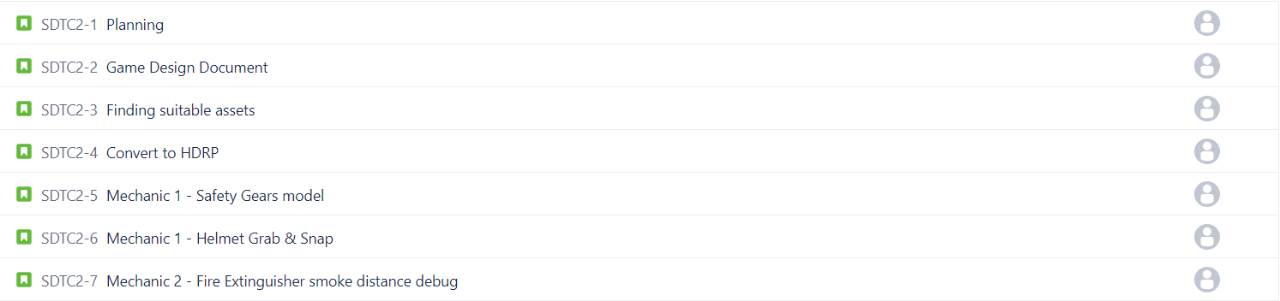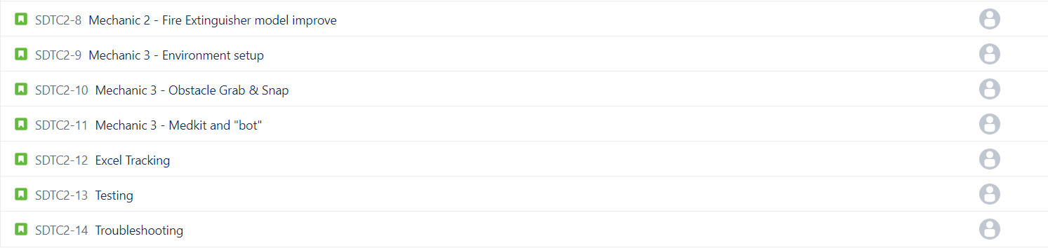

SCRUM – Estimated Effort Chart

|  |  |  |  |
| --- | --- | --- | --- |
| **Task** | **Manhour Needed** | **Date Range (Est.)** | **Assignee** |
| Planning | 3 | 18/1/21 – 18/1/21 | Tenia & Sebastian |
| Game Design Document | 2 | 18/1/21 – 18/1/21 | Tenia & Sebastian |
| Finding suitable assets | 5 | 18/1/21 – 18/1/21 | Tenia & Sebastian |
| Convert to HDRP | 5 | 19/1/21 – 19/1/21 | Tenia |
| Add “Restart” button | 1 | 19/1/21 – 19/1/21 | Sebastian |
| Add “Quit” button | 1 | 19/1/21 – 19/1/21 | Sebastian |
| Mechanic 1 (touch ups) | 15 | 20/1/21 – 22/1/21 | Tenia |
| Mechanic 2 | 20 | 25/1/21 – 27/1/21 | Tenia & Sebastian |
| Excel Tracking | 10 | 28/1/21 – 29/1/21 | Sebastian |
| Mechanic 3 | 25 | 1/2/21 – 4/2/21 | Tenia & Sebastian |
| Add difficulty level | 10 | 4/2/21 – 5/2/21 | Sebastian |
| Testing | 10 | 8/2/21 – 9/2/21 | Tenia & Sebastian |
| Troubleshooting | 20 | 9/2/21 – 11/2/21 | Tenia & Sebastian |

SCRUM – Sprint In Progress

Sprint 1 Duration: 18/1/21 – 22/1/21

Sprint 1 (Before): 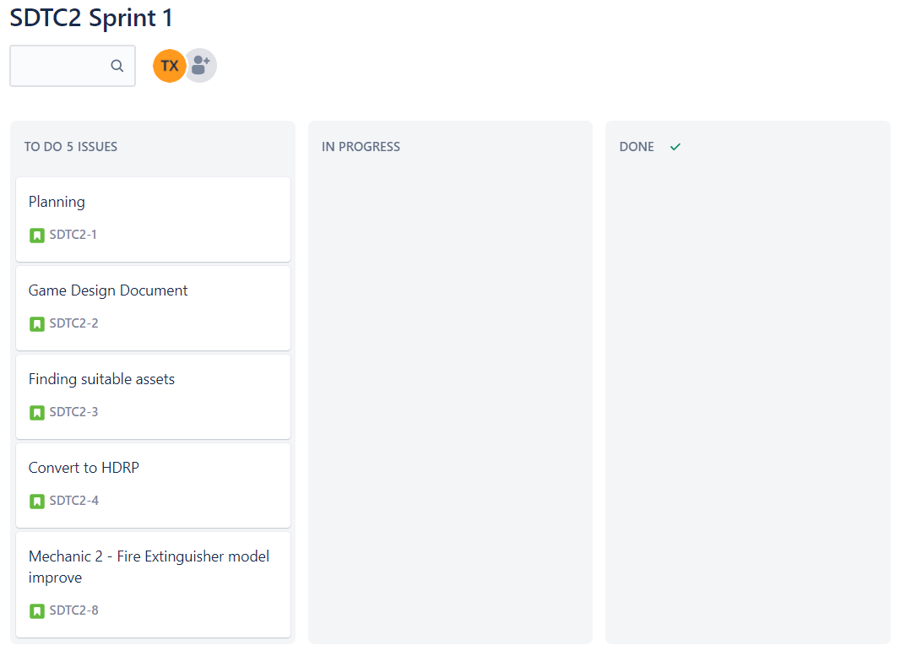

Sprint 1 (During): 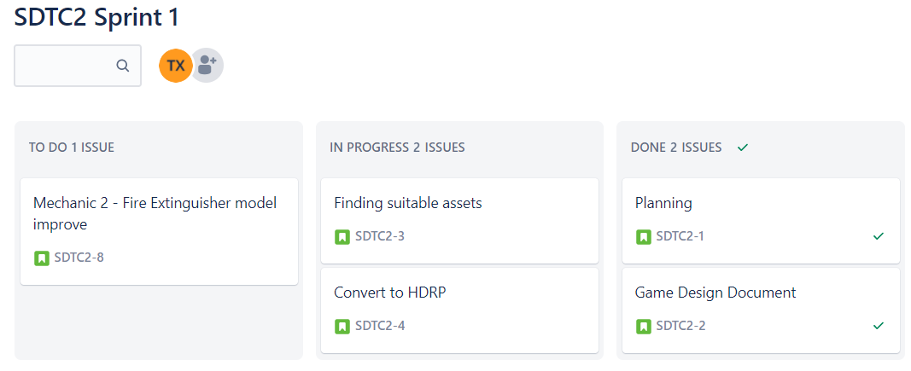

Sprint 1 (After): 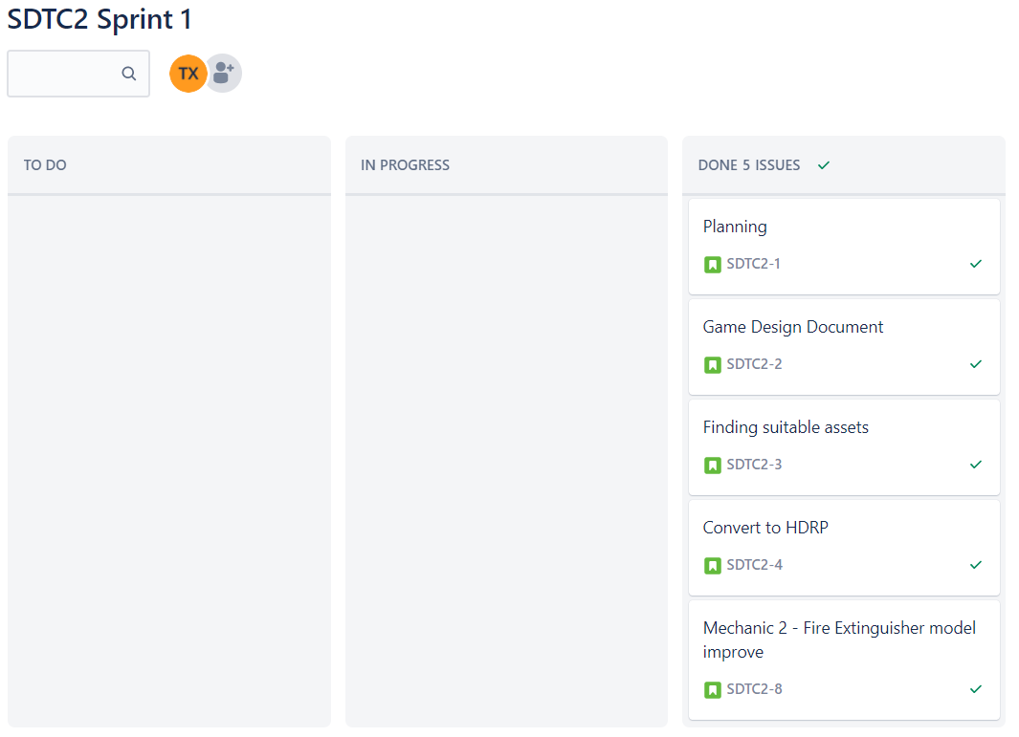

---------------------------------------------------------End of Sprint 1---------------------------------------------------------

Sprint 2 Duration: 25/1/21 – 29/1/21

Sprint 2 (Before): 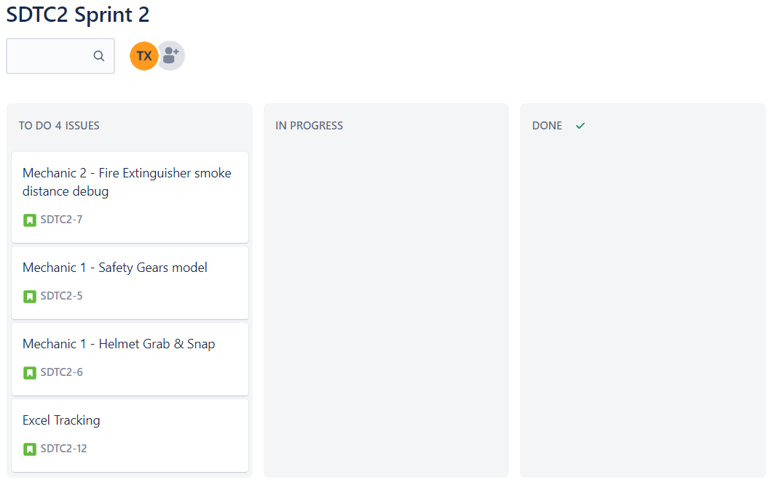

Sprint 2 (During): 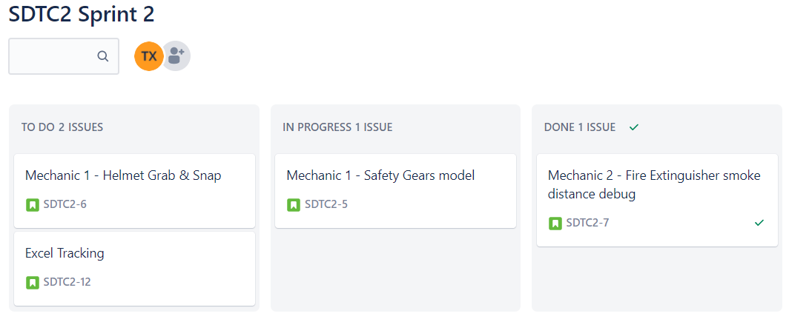Sprint 2 (After): 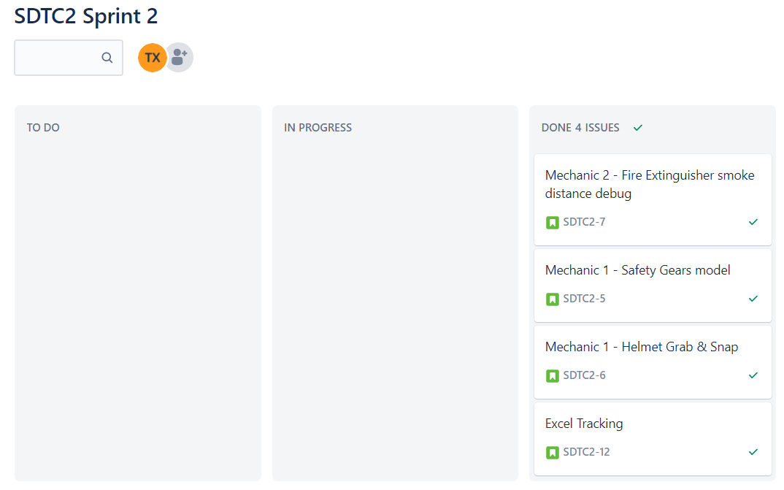

---------------------------------------------------------End of Sprint 2---------------------------------------------------------

Sprint 3 Duration: 1/2/21 – 5/2/21

Sprint 3 (Before): 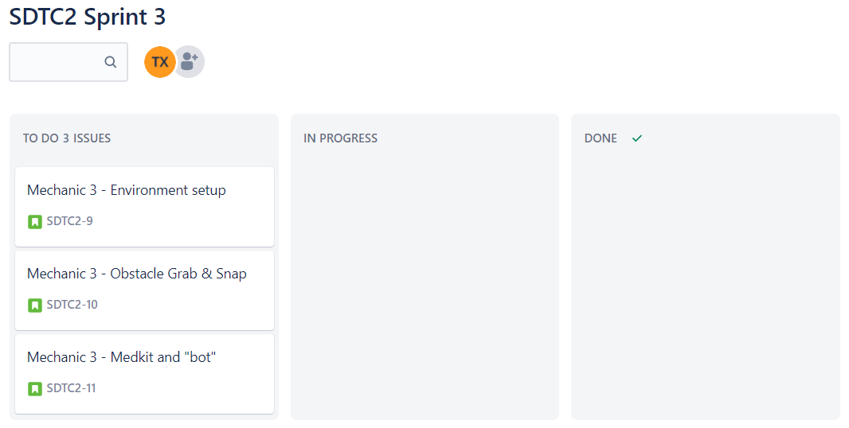

Sprint 3 (During): 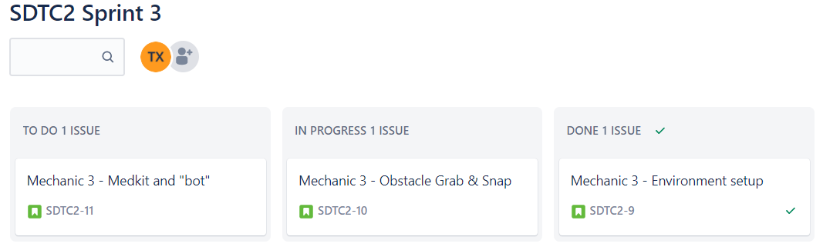

Sprint 3 (After): 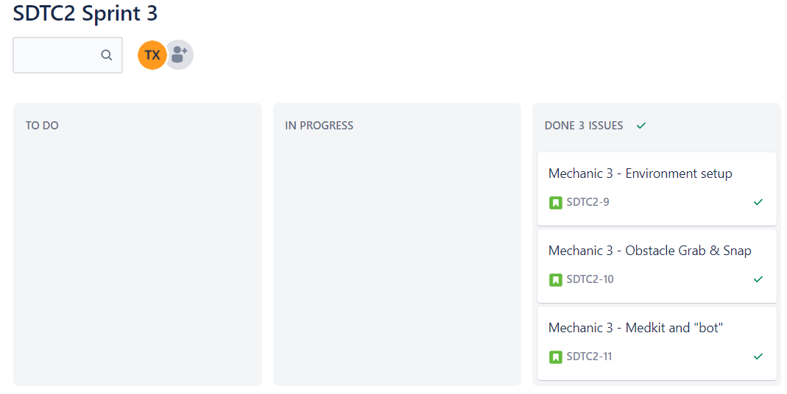

---------------------------------------------------------End of Sprint 3---------------------------------------------------------

Sprint 4 Duration: 8/2/21 – 11/2/21

Sprint 4 (Before): 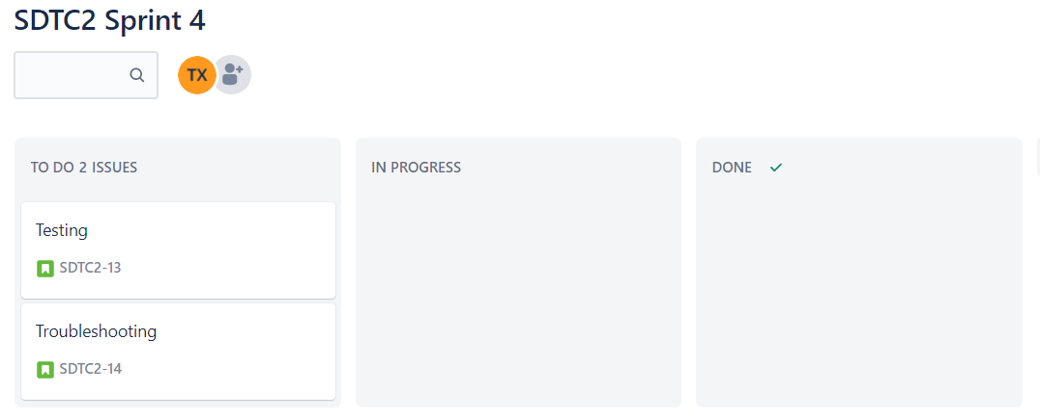

Sprint 4 (During): 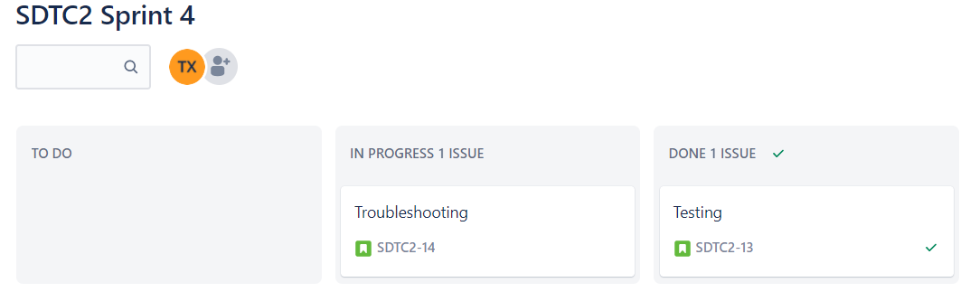

Sprint 4 (After):

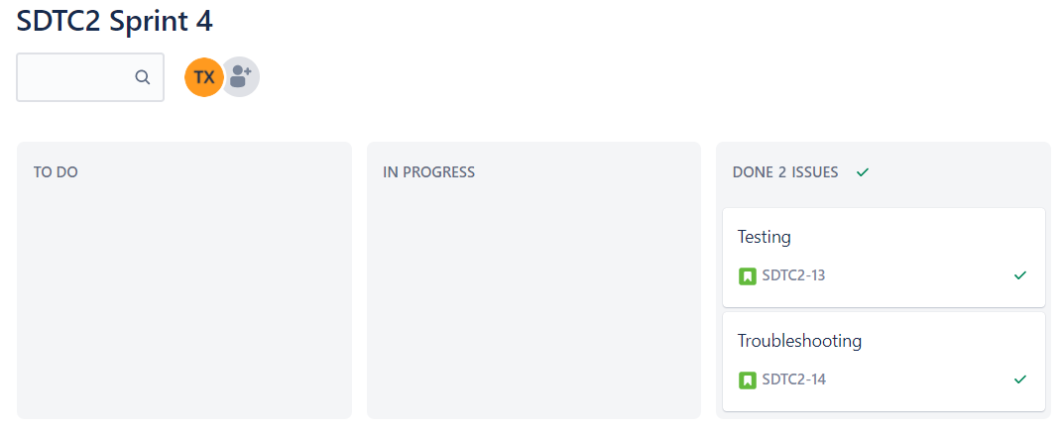

---------------------------------------------------------End of Sprint 4---------------------------------------------------------

SCRUM – Burndown Chart

